### 

### 

### 

### Descript: A Promising Tool for Easy Production of Audio-Only Content

By

Adam Hill

for

Dr. Brian Beatty

ITEC 830

Design of Learning Environments with Emerging Technologies

San Francisco State University

March 9, 2023

### Introduction

For the past eight years, I have worked as an instructional designer for 2U, an online program management (OPM) company, where I collaborate with university faculty to design blended async-sync online courses for graduate-level learners. Across the thousands of courses 2U has built for universities for nearly 15 years, the primary delivery modality for asynchronous instruction has always been high-quality, recorded video. We have done little venture into producing audio-only instructional content for learners, despite evidence that audio-only content is optimal for some e-learning contexts (Clark & Mayer, 2011). In fact, despite our robust video production operations, we don’t even have a production process for producing any audio-only content, and some of the LMS that we use don’t even have a native audio player.

Given the prevalence of podcasts[1] in our culture (Ruby, 2023), and online learners’ preferences for flexible learning in which audio-learning would allow for more learning on the go, there is clearly a need to explore platforms that support audio-only production. Personally, I have been curious about the use of audio-only content for instructors to lecture briefly on a topic that requires no visual aids, or for recording interviews. In both of these contexts, the video presence of a person might not actually enhance the learning content and could even be distracting for students, adding extraneous cognitive load. This scenario has gotten me curious about platforms that allow for the easy production of audio content.

#### Demonstration: Descript

Descript is an all-in-one video and audio editing platform that concisely presents itself as “the simple, powerful, and fun way to edit.” (Descript, 2023). What makes Descript different from other editing software like Final Cut Pro, Adobe Premiere, or GarageBand, is that Descript primarily uses a script to edit content rather than a timeline to edit content.

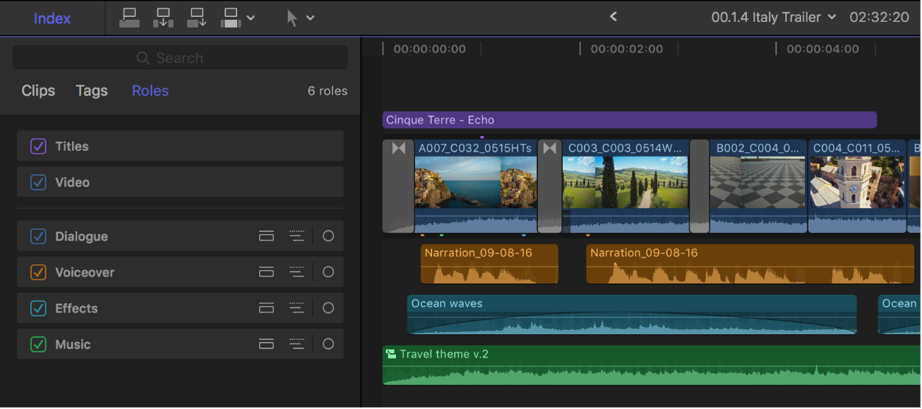 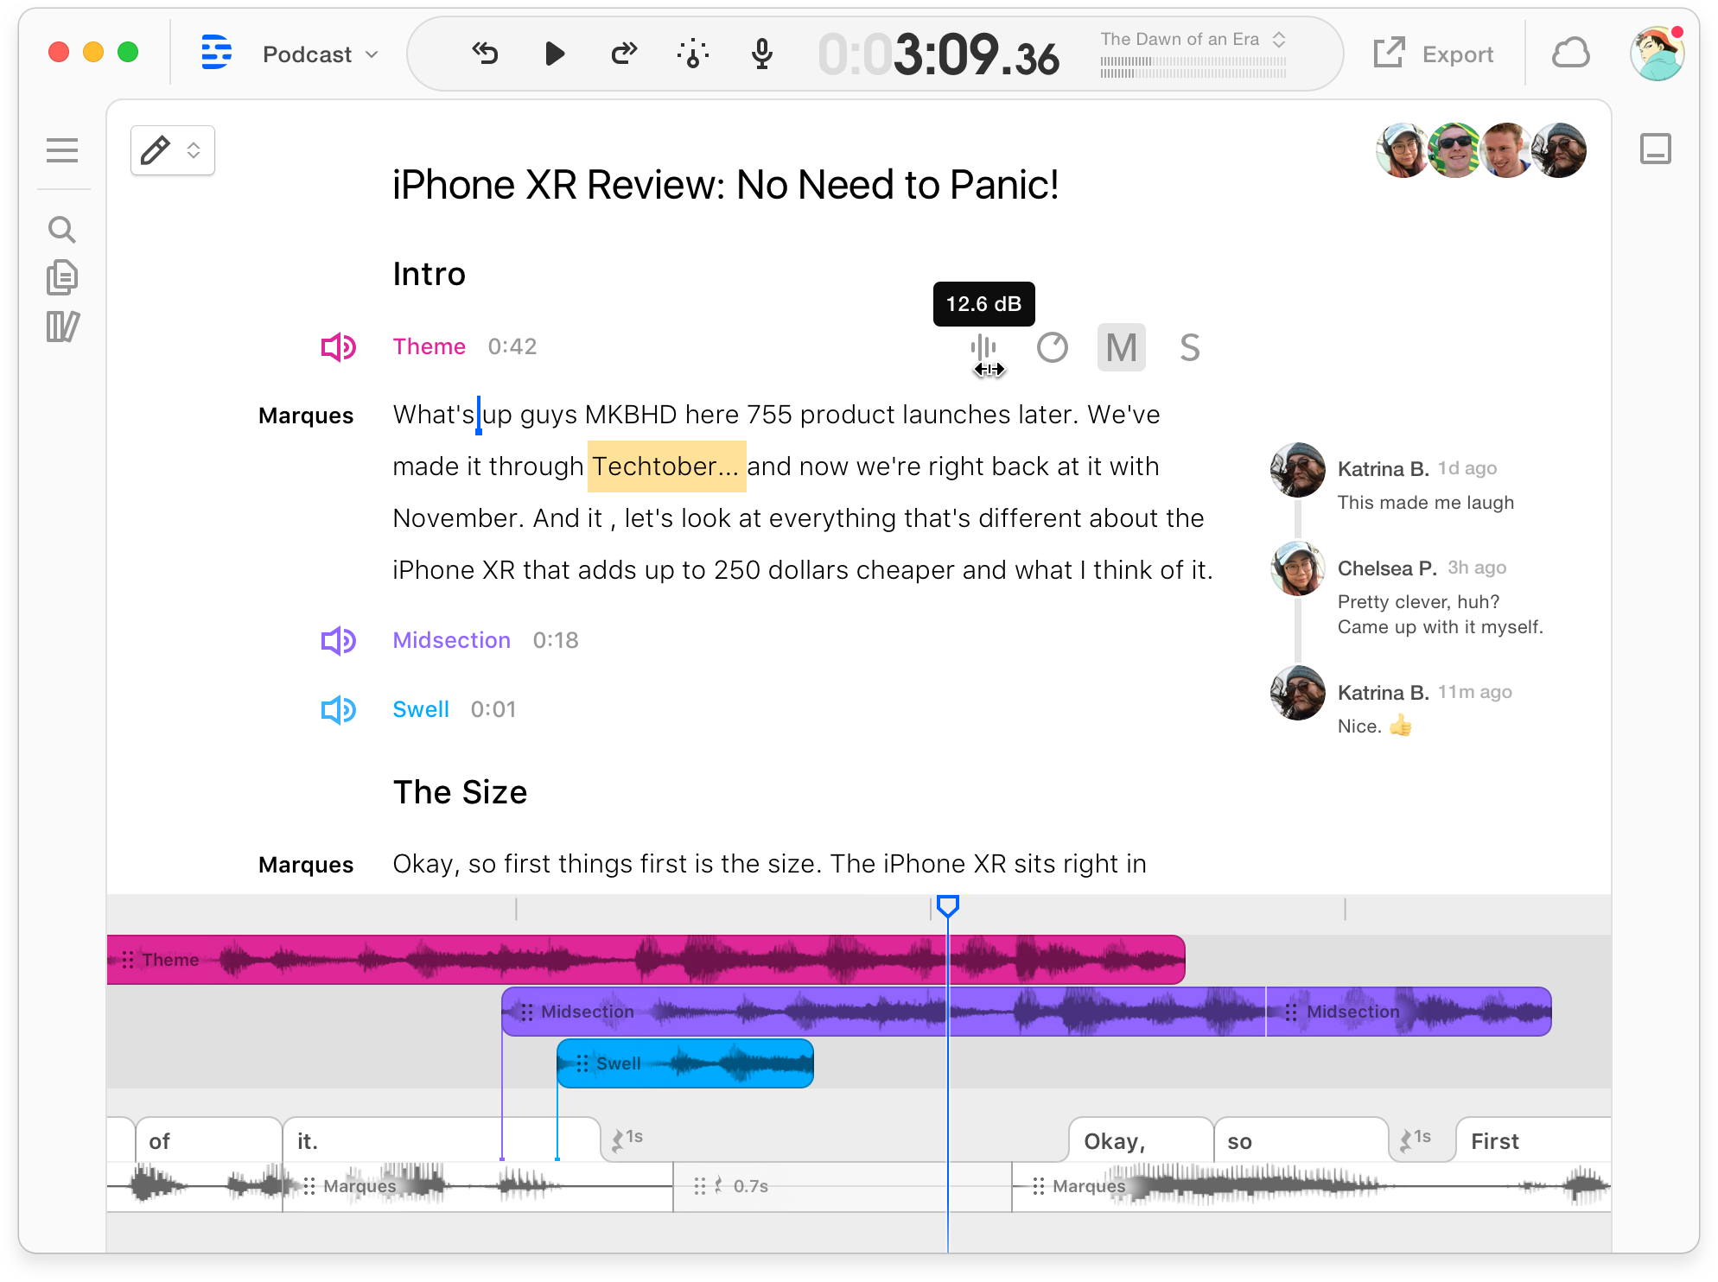

Figure 1: Timeline editing in Final Cut Pro (left; Apple, 2023) vs. script editing in Descript (right).

For the purposes of this paper, I am primarily focusing on Descript’s capabilities for audio production. You can download Descript for free directly from [their website](https://www.descript.com/) and use it on your Mac or PC and produce up to 60 minutes of content.   
**Step 1: Record your audio content.**

To get started using Descript, you will need an audio file. I simply recorded a short 3-minute snippet of audio on my iPhone XR and was able to upload it very quickly to the platform. Alternatively, you can also record your audio directly into the platform, however, I actually found this to be a little more challenging technically.

**Step 2: Editing your audio content.**

After you have uploaded your content, Descript will immediately transcribe your content and render a script for you to begin the editing process.

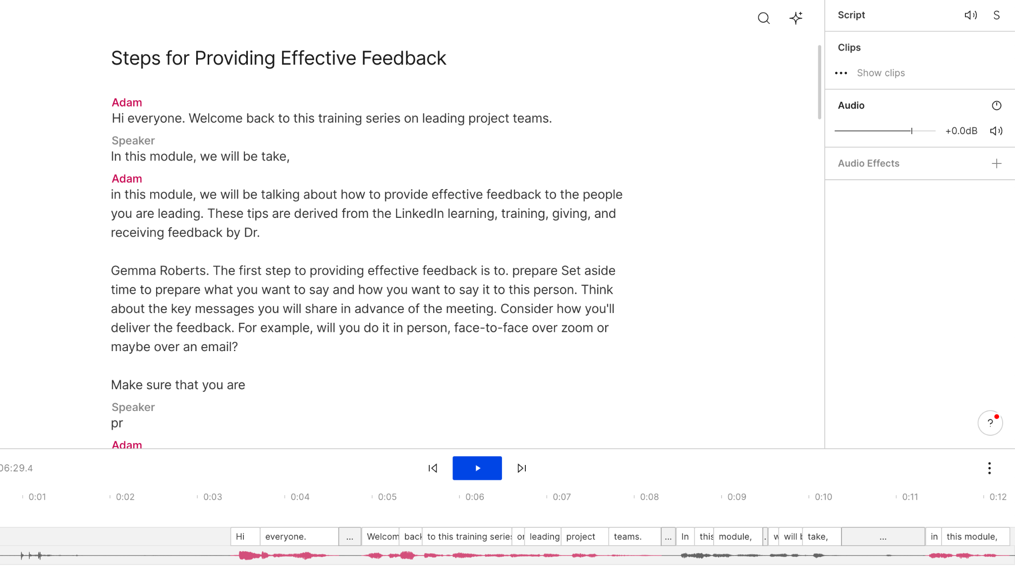

Figure 2: Editing using Descript’s script feature.

I would say that the script is about 75-80% accurate on its own. However, the rendering of the script itself makes editing incredibly easy. In past experiences editing audio, I would have to listen to the full recording of the audio, splice various parts of the audio on the timeline, and play it back numerous times to ensure that I cut just the right parts. The script editing feature saved me lots of time as I was easily able to find my place throughout the editing process and quickly generate a final product.

In addition to the straightforward editing tool over a script, Descript also offers some automation and AI tools that enhance the quality of your video. You can ask Descript to “shorten word gaps'' to allow for a less choppy listening experience. For example, you can identify that any gaps between words of more than three seconds can be shortened to one. You can also ask Descript to “remove filler words” like “uh” and “um”, which also leads to a smoother listening experience. Lastly, you can create an AI version of your voice if you would need to add in some words, without re-recording new audio. (Note: These features were available for the free version, but in limited scope).

**Step 3: Publishing your audio content.**

Once you are done editing your audio, you simply press the “Publish” button in the upper-righthand corner of the platform and it will [publish your content](https://share.descript.com/view/c4WDrncblZv) on an external public website, which is available to your learners.

#### Reflections, applications to education, privacy, and pricing

While Descript is primarily used for professional podcasting and does not position itself as an “edtech” product, I do see a lot of promises for applications in education. Even with my basic hardware (iPhone XR and 2020 laptop), I found the editing process to be incredibly easy and straightforward, producing high-quality audio relatively quickly. The easy publishing of audio content can be embedded into a learning management system (LMS) without relying on native tools within a specific platform, which has been a challenge in my professional context. An instructor can even go back and modify the link if they needed to, which allows for easy iteration of course content. While I do think that audio-only content should completely replace video lectures in online courses, I think that there are use cases for audio-only lectures and interviews that could be better for learning, and Descript is an incredibly promising tool for these endeavors.

Regarding the privacy policies of the product, I found them to be straightforward and transparent. Descript makes clear that all of their user’s products are completely private. There are certain pieces of log in information that are shared automatically, which seems standard for most websites. They do share your information for some advertising purposes. Descript has some AI tools to create an AI version of your voice, which I didn’t do for this project, and there is an option to opt into sharing your voice with Descript to help improve this product (Descript, 2023).

There are 4 [pricing tiers](https://www.descript.com/pricing) for Descript. The free version allows for 60 minutes of transcription per month. The “Creator” tier is priced at $12/month and allows for 10 hours of transcription per month, and the “Pro” tier is priced at $24/month with 30 hours of transcription per month. There is also an “Enterprise” tier which has a custom priced level. Each of the tiers also allow for increased access to automation and AI features like “filler word removal" and “Overdub” Ai voice.

#### References

Apple. (2023, March). [*Final Cut Pro User Guide*](https://support.apple.com/guide/final-cut-pro/organize-the-timeline-with-audio-lanes-verb71cb913/mac)

Clark, R. C. & Mayer, R. E. (2011). *e-Learning and the science of instruction: Proven guidelines for consumers and designers of multimedia learning* (3rd ed.). San Francisco, CA: Pfeiffer/John Wiley & Sons, p. 115.

Descript. (2023, March). [*Homepage*](https://www.descript.com/).

Descript. (2023, March). [*Privacy Policy*](https://www.descript.com/privacy)*.*

Ruby, Daniel. (2023, February 23). *40+ Podcast Statistics For 2023 (New Data, Trends & More).* [Demand Sage](https://www.demandsage.com/podcast-statistics/#:~:text=Here%20is%20the%20list%20of,70%20million%20episodes%20between%20them.).

1. I would consider podcasts to be just one type of audio-only content. Audio-only content could also include audio lectures or interviews and possibly other types.